Day 17 Output:

Home:

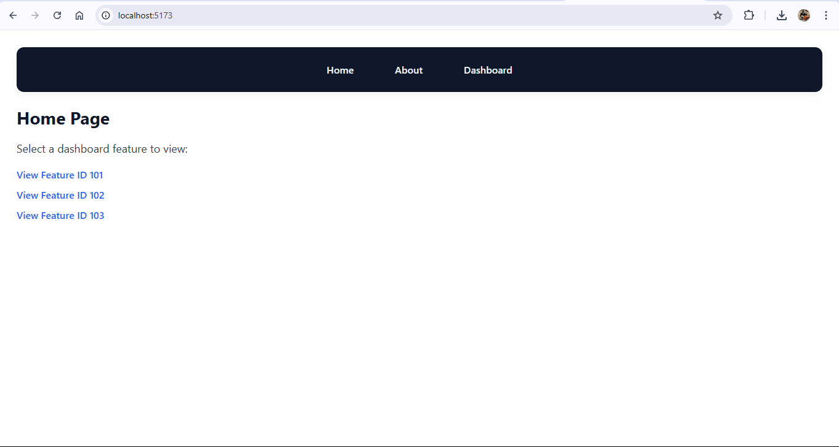

About page:

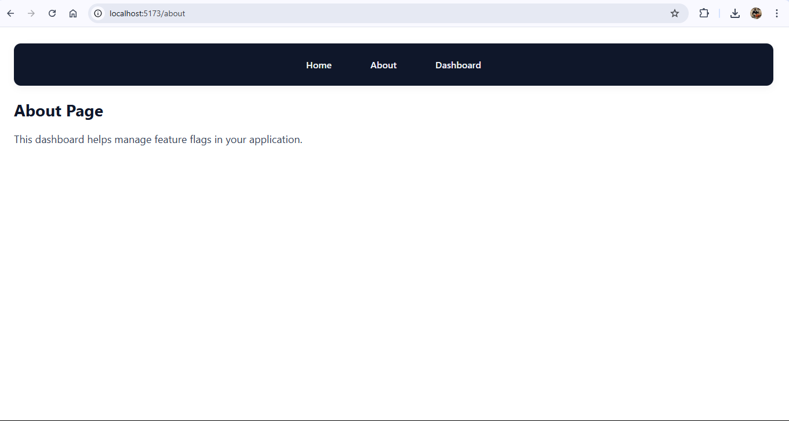

Initial Dashboard Page:

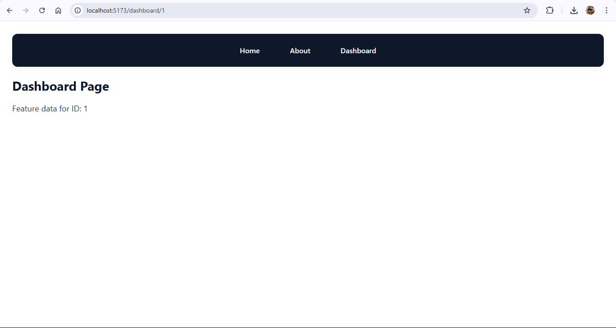

After selecting ID numbers:

[View Feature ID 101](http://localhost:5173/dashboard/101):

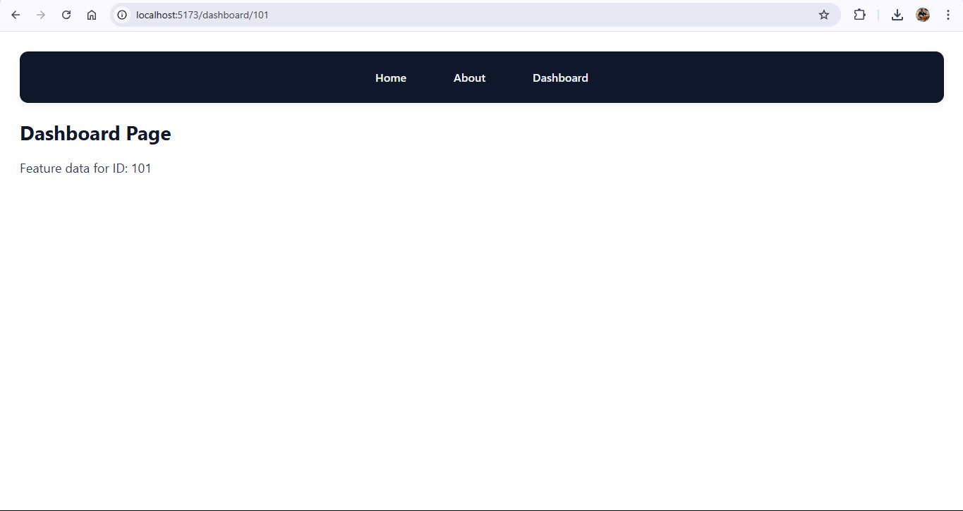

[View Feature ID 10](http://localhost:5173/dashboard/101)2:

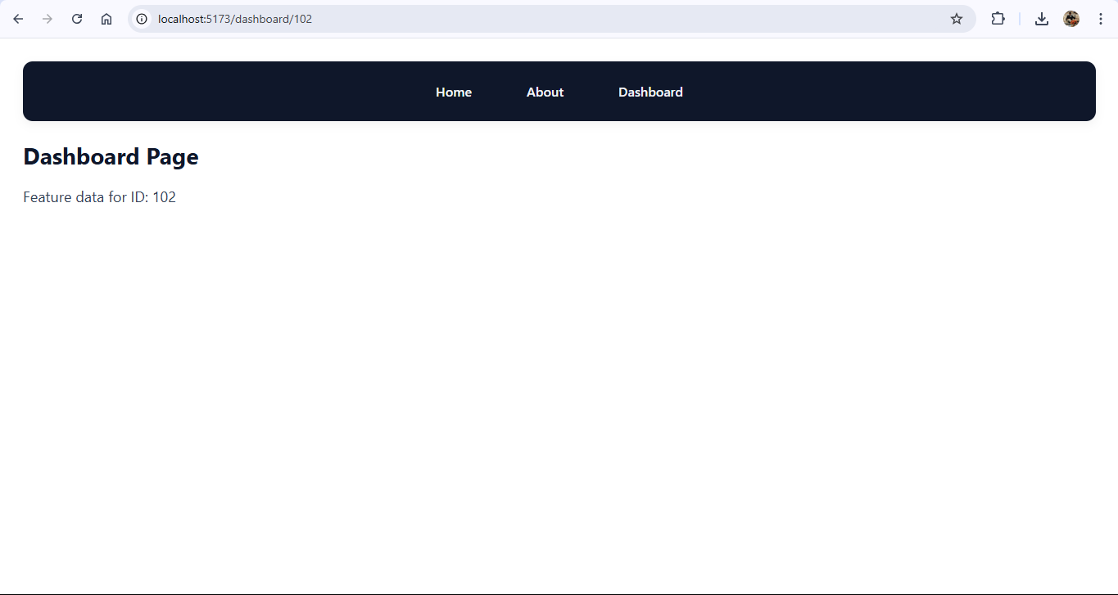

[View Feature ID 10](http://localhost:5173/dashboard/101)3:

